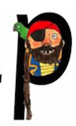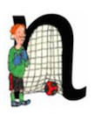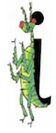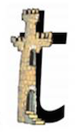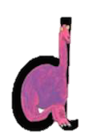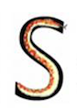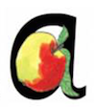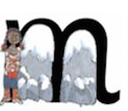

t

Down the tower, across the tower.

d

Around his bottom, up his tall neck and down to his feet.

p

Down the plait, up and over the pirates face.

n

Down Nobby, over his net.

i

Down the body, dot for the head.

s

Slither down the snake.

a

Round the apple and down the leaf.

m

Maisie mountain mountain.

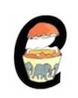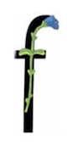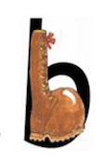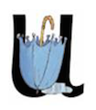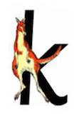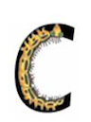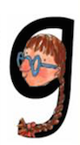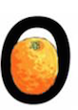

e

Lift off the top, and scoop out the egg.

u

Down and under, up to the top and draw the puddle.

f

Down the stem and draw the leaves.

b

Down the laces to the heel, round the toe.

k

down the kangaroos body, tail and leg.

c

Curl around the caterpillar.

g

Round her face, down her hair, give her a curl.

o

All around the orange.

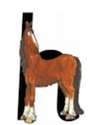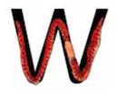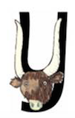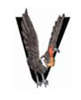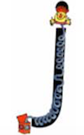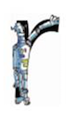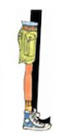

y

Down a horn, up a horn, under his head.

w

down and up, down and up.

v

Down a wing, up a wing.

j

Down his body, curl and dot.

r

Down his back, then curl over his arm.

sh

Ssssh said the horse to the hissing snake.

h

Down the head to the hooves and over his back.

l

Down the long leg.

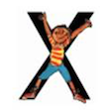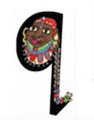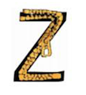

nk

I think I stink.

ng

A thing on a string.

x

Down the arm and leg and repeat the other side.

qu

Round her head, up past her earring and down her hair.

z

Zig zag zig.

ch

The horse sneezes when the caterpillars hairs get up his nose.

th

The princess in the tower, is rescued by the horse.